Mapleson Circuits (C and F)

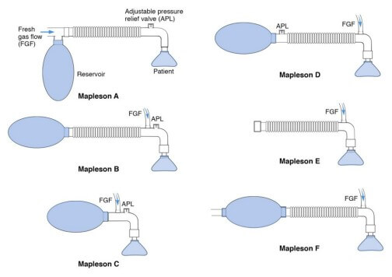

MAPLESON CIRCUITS REQUIRE FRESH GAS FLOW TO BE EFFECTIVE. THESE ARE FLOW INFLATING BAGS NOT SELF INFLATING.

IF NO FRESH GAS FLOW AVAILABLE USE AMBUBAG/ BAG VALVE MASK.

INTRODUCTION

Mapleson breathing systems are used for delivering oxygen and anaesthetic agents and to eliminate carbon dioxide during anaesthesia (Kaul et al., 2013).

There are five basic types of Mapleson system designated in 1954 by William Mapleson: A, B, C, D and E depending upon the different arrangements of these components. Mapleson F was added later in 1975 by Willis, Pender and Mapleson. They consist of various components:

- Fresh gas flow
- Reservoir bag
- Breathing tubes
- Expiratory valve
- Patient connection.
A fresh gas flow (FGF) inlet delivers anaesthetic and fresh gases into the system which builds pressure. Once the pressure exceeds a set value the APL valve opens allowing gases to exit eh breathing system. An open APL valve allows all expired gases to exit the system. Partial closure of the APL valve allows continuous positive airway pressure (CPAP) to be delivered. Because semi-open systems lack components for carbon dioxide absorption, higher FGF rates are necessary to prevent rebreathing and carbon dioxide buildup (Yao et al., 2025).

Mapleson circuits are semi-open and semi-closed systems which enable variable gas control and efficiency. These systems can be connected to a laryngeal mask airway, endotracheal tubes, tracheostomy tubes and face masks. Because they lack unidirectional valves or absorbers, they depend entirely on the FGF to flush out exhaled alveolar gas from the circuit before the next breath.

Mapleson circuits can be directly connected to a ventilator for advanced respiratory monitoring. This allows for tracking of minute ventilation, tidal volumes, capnography, pressures, and waveforms which enhance patient safety during preoxygenation and intubation. Clinicians can seamlessly transition from spontaneous to controlled ventilation by adjusting the APL valve, benefiting from the tactile feedback from the soft reservoir bag. This ensures effective ventilation and secure preoxygenation, particularly crucial in high-risk intubations (Khoury et al., 2014). While the Mapleson C circuit offers certain advantages, it is crucial to note its weaknesses. It requires trained personnel familiar with this equipment and a continuous gas supply (Stężewska & Zawadka, 2024).
Mapleson C

- Structure: It has fresh gas entry and APL valve located near the patient end, and unlike the Mapleson B, lacks corrugated tubing, reducing mechanical dead space and minimising the risk of rebreathing.
- Usage: Commonly used for emergency resuscitation, patient transfer, and providing manual ventilation as it allows for high-quality, controlled ventilation.
- Rebreathing & Flow Rates: Preventing CO2 rebreathing requires high fresh gas flows—often at least twice the patient's minute ventilation.
- Advantages: Portable, simple, allows for excellent tactile feedback of lung compliance and provides better oxygenation for pre-oxygenation compared to some self-inflating bags.
- Limitations: It requires a continuous gas source (cannot work without one, unlike a self-inflating bag) and constant manual operation by a trained professional.

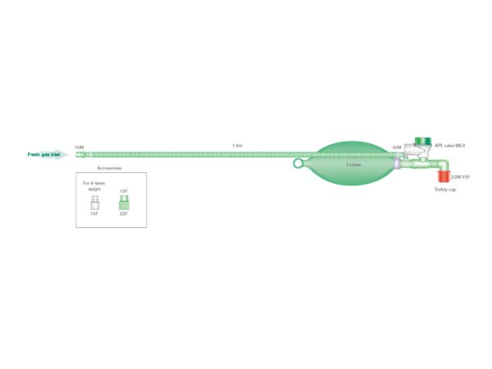

Mapleson F

- Also known as Jackson-Rees modification of Ayres T Piece
- Usage: Ideal for paediatrics (under 6 years old) or infants with tidal volumes less than 300ml. Normally used for paediatric patients under 20kg.
- Structure: It features a valve-less T-piece with a reservoir bag attached to the expiratory limb, offering low resistance, low dead space, and suitability for both spontaneous and controlled ventilation.
- Advantages: Offers very low resistance to breathing, allows easy spontaneous breathing, and provides a clear view of ventilation through the breathing bag.
- Ventilation: The reservoir bag (500ml) allows for manual ventilation (assisted/controlled) by bagging, while its elasticity provides pressure buffering to reduce barotrauma risks.
- Requirements: Requires high fresh gas flows (FGF), often 2–3 times the minute ventilation, to prevent rebreathing of CO2.
Limitations:
- Environmental/Costs: High FGF usage results in significant waste of anaesthetic gases and environmental pollution.
- Scavenging: Difficulty in scavenging waste anaesthetic gas (WAG) at the bag’s tail.
- Safety: While better than the Mapleson E, improper usage can still lead to high airway pressures or rebreathing.

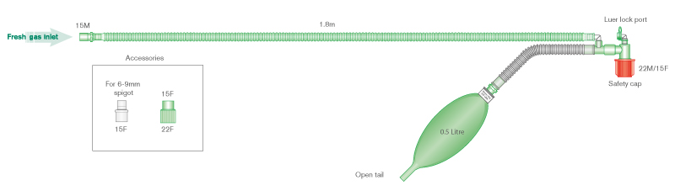

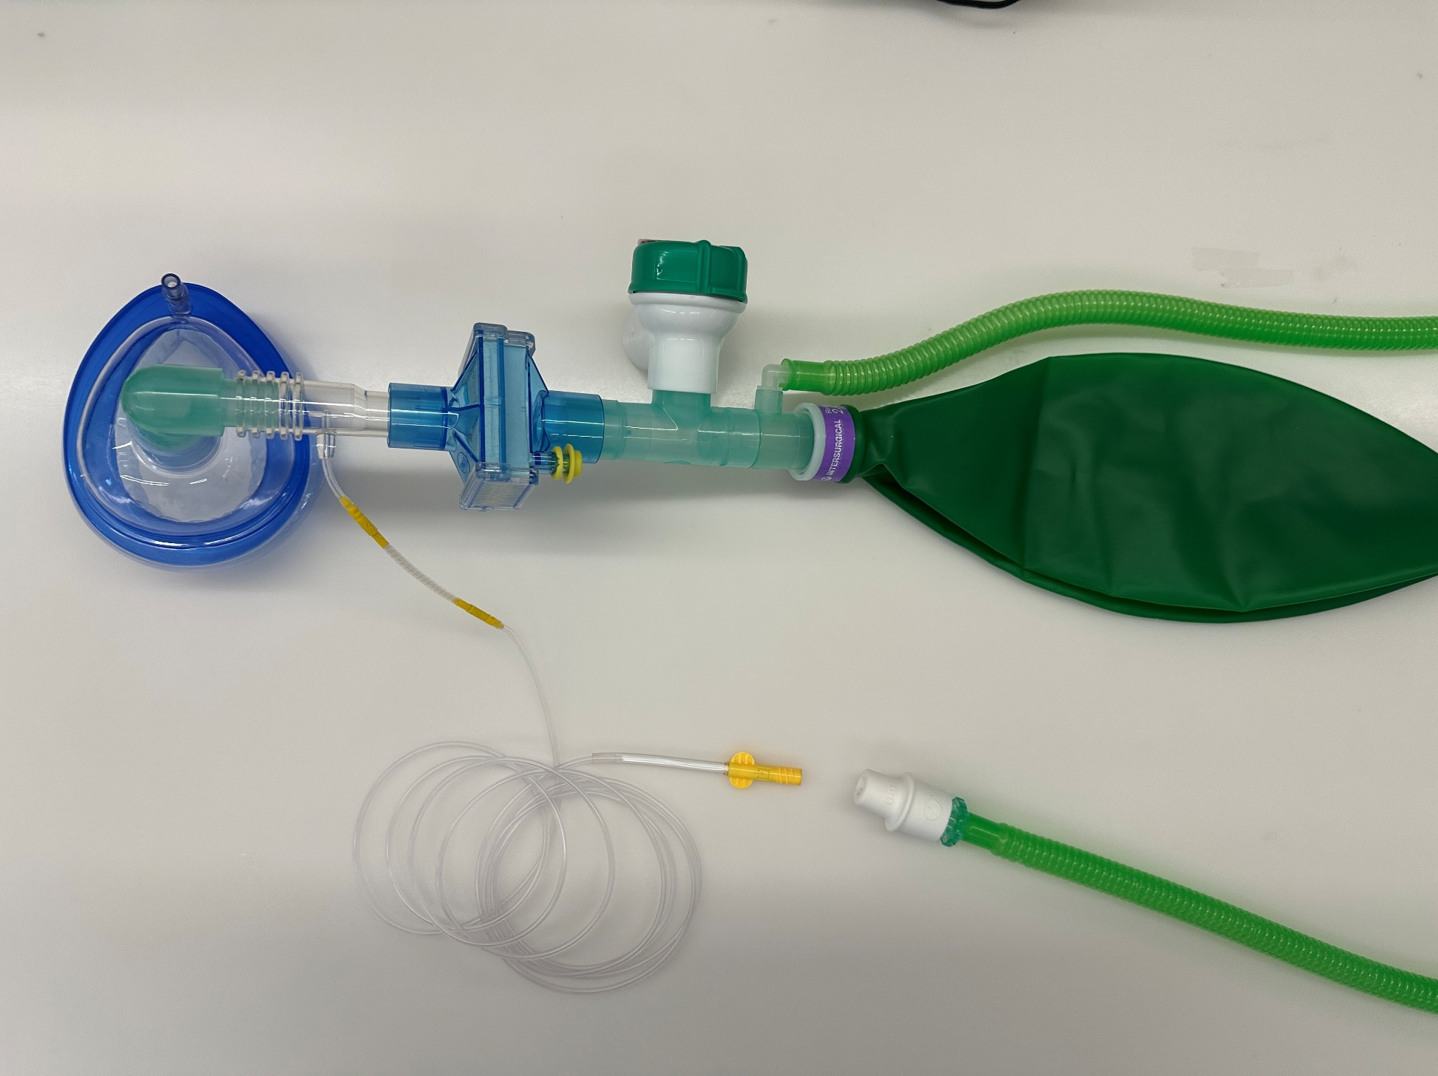
MAPLESON C CIRCUIT
Fresh gas flow inlet
APL Valve
White oxygen tap connector. When removed can connect to ACGO
Capnography. Can connect to Phillips monitoring port
2L Reservoir bag
Capnography connector (Can connect to male luer sample line to an anaesthetic machine)
Airway device:
- Face mask
- LMA
- ETT
HME filter
Elbow (comes in pack)

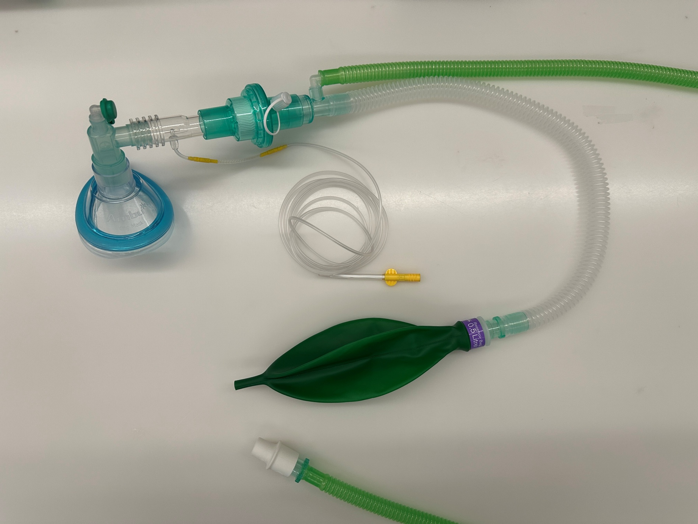
MAPLESON F CIRCUIT
Capnography. Connect to Phillips monitoring port
Fresh gas flow inlet
HME filter
Elbow (comes in pack)
Expiratory limb
White oxygen tap connector. When removed can connect to ACGO
Airway device:
- Face mask (appropriate size)
- LMA
- ETT
500ml bag with open tail. Pinch with fingers to alter PEEP.

References

Kaul, T. K. & Mittal, G., 2013. Mapleson's breathing systems. Indian Journal of Anaesthesia, 57(5), pp. 507-515.
Khoury, A. et al., 2014. From Mouth-to-Mouth to Bag-Valve-Mask Ventilation: Evolution ad Characteristics of Actual Devices - A Review of the Literature. Biomed Research International, 762053(10), p. 6.
Stężewska, A. & Zawadka, M., 2024. Optimising preoxygenation in critically ill patients. A comparitve analysis of the self- inflating bag valve mask and the Mapleson C Circuit. Anaesthesiology Intensive Therapy, 56(1), pp. 83-85.
Yao, P., Hendrix, J. & Stahl, D., 2025. Anesthesia Breathing Systems. [Online]
Available at: https://www.ncbi.nlm.nih.gov/books/NBK574503/
[Accessed 23 March 2026].

