COMMON ANAESTHETIC DRUGS

Emergency
Common concentration: 200mcg/ml
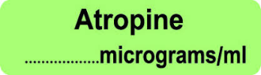
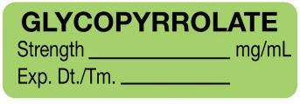
Common concentration:
- 600mcg/ml
- 1200mcg/ml
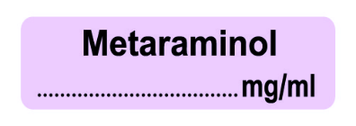
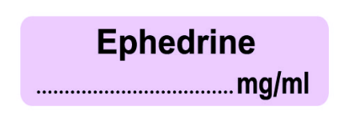
Common concentration:
- 10mg/ml
Most often diluted to 0.5mg/ml. Can come in prefilled syringe (2.5mg/5ml) or for infusion dilute 10mg/1ml ampoule in



Reversals





Opioids
