MY SMARTPHRASES – SDPR

Phrases highlighted in green are shortcut phrases. You do not need to write the dot in front when entering a shortcut phrase into EPIC. Only need the dot when using on notes.

Creating your own Smartphrase


Use the search function to look for ‘My Smartphrases”. The Smartphrase tab will open.

Click on “New User Smartphrase”

Enter your template here. This will be the body of text that appears when you input your shortcut phrase.
The “Name” panel will be the shortcut phrase you will use to access the whole template

You can share your personal templates with other members of the team by adding their names to the “Sharing” tab.
Click “Accept” once you have finished creating your Smartphrase.

Your new SmartPhrase will appear in the Smartphrase tab.

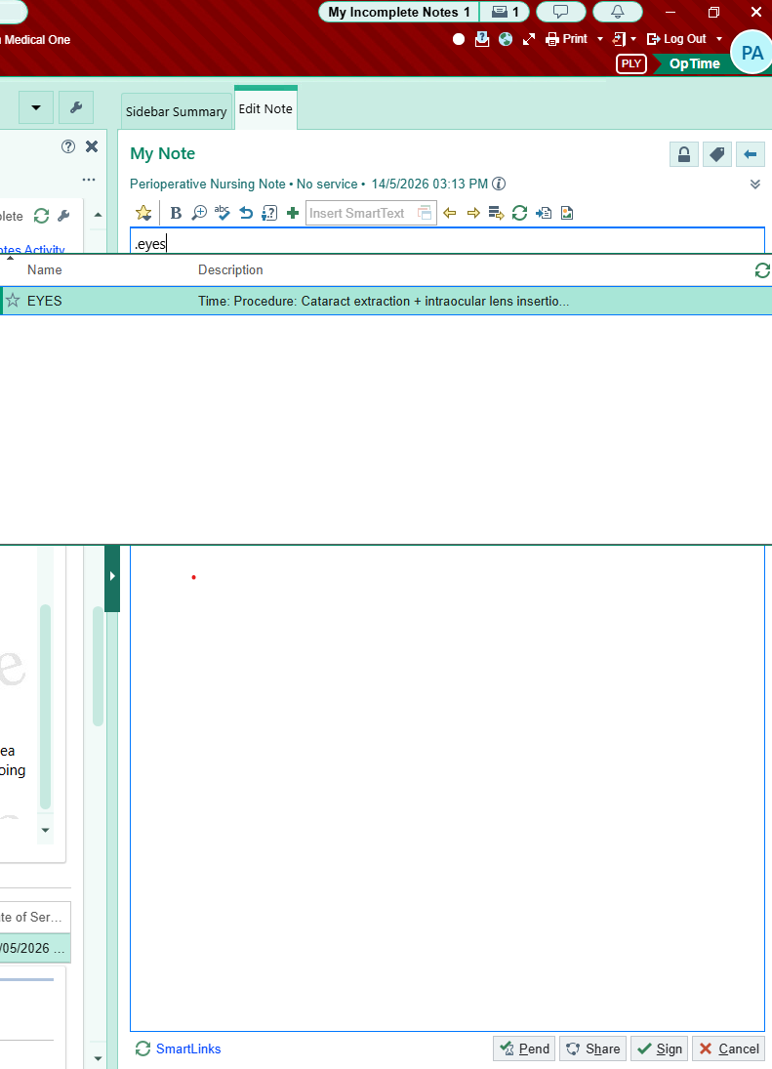

When you want to use a template enter your shortcut phrase with a ‘.’ before the phrase. For example, my phrase is ‘EYES’ so the phrase is inputted as “.EYES”. After writing your shortcut phrase and pressing enter the notes section will auto populate with the template you have created.

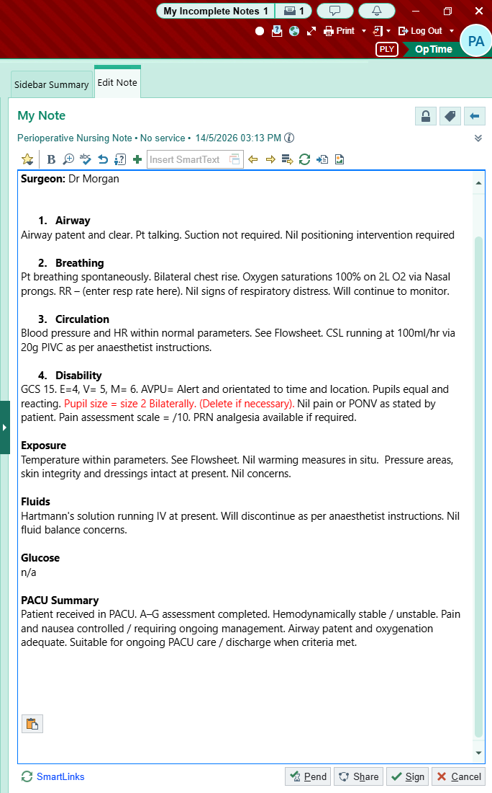

Alter your template as required. Click Sign when you have finished with your note or “Pend” if you need to come back to your notes.

TEMPLATES

Phrases highlighted in green are shortcut phrases. You do not need to write the dot in front when entering a shortcut phrase into EPIC. Only need the dot when using on notes.

A2GPACU

STANDARD PACU A-G ASESSMENT

Airway
Airway patent and clear. Pt talking. Suction not required. Nil positioning intervention required

Breathing
Pt breathing spontaneously. Bilateral chest rise. Oxygen saturations 100% on 6L O2 via Hudson mask. RR – (enter resp rate here). Nil signs of respiratory distress. Will continue to monitor.

Circulation
Blood pressure and HR within normal parameters. See Flowsheet. Nil bleeding from surgical site. CSL running at 100ml/hr via 20g PIVC as per anaesthetist instructions.

Disability
GCS 15. E=4, V= 5, M= 6. AVPU= Alert and orientated to time and location. Pupils equal and reacting. Pupil size = size 2 Bilaterally. (Delete if necessary). Pain assessment scale = /10. PRN analgesia available if required.

Exposure
Temperature within parameters. See Flowsheet. Nil warming measures in situ. Pressure areas, skin integrity and dressings intact at present. Nil concerns.

Fluids
Hartmann’s solution running IV at present. Will continue/ discontinue as per anaesthetist instructions. Nil fluid balance concerns.

Glucose
n/a

PACU Summary
Patient received in PACU. A–G assessment completed. Hemodynamically stable / unstable. Pain and nausea controlled / requiring ongoing management. Airway patent and oxygenation adequate. Suitable for ongoing PACU care / discharge when criteria met.
A2GCPACU
COMPREHENSIVE PACU A–G ASSESSMENT
Time:
Procedure:
Anaesthetist:
Surgeon:

A – Airway
- Airway patent: Yes / No
- Airway adjunct in situ: Nil / OPA / NPA / LMA / ETT
- Able to talk appropriately: Yes / No
- Stridor / obstruction / secretions: Yes / No
- Cervical spine precautions: Yes / No
B – Breathing
- RR: /min
- SpO₂: %
- Oxygen delivery: Room air / NP / Hudson / simple mask / HFNP
- O₂ flow rate: L/min
- Work of breathing: Normal / increased
- Chest expansion equal: Yes / No
- Breath sounds: Clear / decreased / wheeze / crackles
- ETCO₂ (if applicable):
C – Circulation
- HR: ____ bpm
- Rhythm: Sinus / AF / other ______
- BP: ____ /____ mmHg
- Cap refill: <2 sec / delayed
- Peripheral perfusion: Warm / cool
- IV access patent: Yes / No
- IV fluids running: Yes / No
- Blood loss concerns: Yes / No
- Drain output:
- Surgical site bleeding: Nil / minimal / moderate / significant
D – Disability
- Conscious state: Awake / drowsy / rousable / unresponsive
- GCS: /15 E= V= M=
- Pain score: /10
- PONV: Yes / No
- Pupils equal/reactive: Yes / No
- Motor/sensory block present: Yes / No
- Bromage score (if spinal/epidural):
- BGL (if indicated): mmol/L
E – Exposure / Environment
- Temperature: °C
- Warming measures in use: Yes / No
- Pressure areas checked: Yes / No
- Skin integrity concerns: Yes / No
- Dressings intact: Yes / No
- Lines/drains/catheters secured: Yes / No
F – Fluids
- IV fluids administered:
- Urine output:
- IDC in situ: Yes / No
- Fluid balance concerns: Yes / No
G – Give Medications / Goals / Plan
- Analgesia administered:
- Antiemetics administered:
- Other medications:
- Discharge criteria met: Yes / No
- Awaiting review by: Anaesthetics / Surgical / APS / Nil
- Planned destination: Ward / HDU / ICU / Home
- Ongoing concerns/escalation:

PACU Summary
Patient received in PACU. A–G assessment completed. Hemodynamically stable / unstable. Pain and nausea controlled / requiring ongoing management. Airway patent and oxygenation adequate. Suitable for ongoing PACU care / discharge when criteria met.

SPINALOBS

SPINAL OBSERVATIONS
Time:
Indication: Post spinal / epidural anaesthesia monitoring

Neurological Assessment
- Conscious state: Alert / drowsy / other:
- Pain score: /10
- Nausea/vomiting: Yes / No
- Headache: Yes / No
- Pruritus: Yes / No

Motor Block – Bromage Score
- Bromage:
Bromage Scale:
- 0 = Full movement of hips, knees and ankles
- 1 = Unable to raise extended leg; able to move knees and feet
- 2 = Unable to raise leg or flex knees; able to move feet
- 3 = Complete block of lower limbs

Sensory Block Assessment
- Tested using: Cold / light touch / sharp sensation
- Highest dermatome level:
  - Left: T
  - Right: T
- Regression of block since previous assessment: Yes / No

Dermatome Landmarks
- T4 = Nipples
- T6 = Xiphisternum
- T10 = Umbilicus
- L1 = Groin
- S1 = Lateral foot
- S2–4 = Perineum

Other
- IV fluids running: Yes / No
- Urinary retention symptoms: Yes / No
- Catheter in situ: Yes / No
- Escalation required: Yes / No

Plan
- Continue routine spinal observations
- Anaesthetic team aware if block rising / prolonged / asymmetrical
- Next review in mins

EYESOBS

Time:
Procedure: Cataract extraction + intraocular lens insertion
Anaesthetist: Dr
Surgeon: Dr Morgan

Airway
Airway patent and clear. Pt talking. Suction not required. Nil positioning intervention required.

Breathing
Pt breathing spontaneously. Bilateral chest rise. Oxygen saturations 100% on 2L O2 via Nasal prongs. RR – (enter resp rate here). Nil signs of respiratory distress. Will continue to monitor.

Circulation
Blood pressure and HR within normal parameters. See Flowsheet. CSL running at 100ml/hr via 20g PIVC as per anaesthetist instructions.

Disability
GCS 15. E=4, V= 5, M= 6. AVPU= Alert and orientated to time and location. Pupils equal and reacting. Pupil size = size 2 Bilaterally. (Delete if necessary). Nil pain or PONV as stated by patient. Pain assessment scale = /10. PRN analgesia available if required.

Exposure
Temperature within parameters. See Flowsheet. Nil warming measures in situ. Pressure areas, skin integrity and dressings intact at present. Nil concerns.

Fluids
Hartmann’s solution running IV at present. Will discontinue as per anaesthetist instructions. Nil fluid balance concerns.

Glucose
n/a

PACU Summary
Patient received in PACU. A–G assessment completed. Hemodynamically stable / unstable. Pain and nausea controlled / requiring ongoing management. Airway patent and oxygenation adequate. Suitable for ongoing PACU care / discharge when criteria met.
SCOPESOBS

Time:
Procedure: Gastroscopy + Colonoscopy +/- biopsies (Delete as required)
Anaesthetist: Dr
Surgeon: Dr

Airway
Airway patent and clear. Suction not required. Nil positioning intervention required as already in left lateral position.

Breathing
Pt breathing spontaneously. Bilateral chest rise. Oxygen saturations 100% on 6L O2 via High flow nasal prongs. RR – (enter resp rate here). Nil signs of respiratory distress. Will continue to monitor.

Circulation
Blood pressure and HR within normal parameters. See Flowsheet.

Disability
GCS 15. E=4, V= 5, M= 6. AVPU= Pt emerging from sedation. Will continue to monitor. Pupils equal and reacting. Pupil size = size 2 Bilaterally. (Delete if necessary). Nil pain or PONV as stated by patient. Pain assessment scale = /10. PRN analgesia available if required.

Exposure
Temperature within parameters. See Flowsheet. Nil warming measures in situ. Pressure areas, skin integrity and dressings intact at present. Nil concerns.

Fluids
Hartmann’s solution running IV at present. Will discontinue as per anaesthetist instructions. Nil fluid balance concerns.

Glucose
n/a

PACU Summary
Patient received in PACU. A–G assessment completed. Hemodynamically stable / unstable. Pain and nausea controlled / requiring ongoing management. Airway patent and oxygenation adequate. Suitable for ongoing PACU care / discharge when criteria met.
CAEOBS
PACU POST-CAESAREAN SECTION NOTES
Patient received in PACU following LSCS / Caesarean section under [spinal / epidural / GA / CSE].
Airway: Patent. Speaking full sentences / maintaining airway independently.
Breathing: RR , SpO2 % on O2.
Circulation: HR bpm, BP / . Peripheries warm and well perfused. EBL intra-op mL.
Neurological: Awake, alert and oriented. Dense neuraxial block resolving appropriately. Motor/sensory level improving.
Pain: /10. Analgesia adequate with multimodal regimen.
Nausea/Vomiting: Nil / controlled with antiemetics.
Uterus: Fundus firm, central and cm under umbilicus. Confirmed by midwife. PV loss scant/moderate/rubra and appropriate.
Wound/Dressing: Clean, dry and intact.
Urine Output: IDC in situ draining clear urine. UO mL/hr.
IV Access/Fluids: PIVC Size: and patent. Fluids as charted.
Medications Given in PACU:
- Analgesia:
- Antiemetic:
- Other:
Assessment:
Stable post-operatively following Caesarean section. No immediate anaesthetic or surgical concerns identified. Baby
Reviewed by:
Time:

.JOINTOBS

Procedure:
Laterality:
Anaesthetist: Dr
Surgeon: Dr
Patient arrived to PACU. Report received from anaesthesia and surgical team.
Airway: Patent / maintaining airway independently.
Respiratory: Breathing unlaboured. RR= . SpO2= at L/min via .
Cardiovascular: Hemodynamically stable.
Neuro: Awake, alert, oriented to time and location. Obeys commands. Spinal in situ.
Dermatomes= Right T , Left T . Bromage score =
Pain: Pain controlled at this time. Current pain score: /10.
Nausea/Vomiting: Denies nausea/vomiting.
Surgical Site: Dressing clean, dry, intact. No excessive drainage noted.
Extremity Assessment:
- Distal pulses intact
- Cap refill < 2 sec
- Motor/sensation intact to operative extremity
- SCDs in place
Lines/Drains:
- IV patent and infusing
- Urinary catheter :
Medications given in PACU: See MAR.
PACU Summary
Patient received in PACU. A–G assessment completed. Hemodynamically stable / unstable. Pain and nausea controlled / requiring ongoing management. Airway patent and oxygenation adequate. Suitable for ongoing PACU care / discharge when criteria met.

